Silent Reading Project

Letter to the Author
Write a letter to the author giving your reaction to the book using the friendly letter format.
Items that you might discuss in your letter include:
- your reaction to the story
- your reaction to the main character(s)
- what you liked or didn’t like about the plot
- why you would or would not recommend this book to a friend

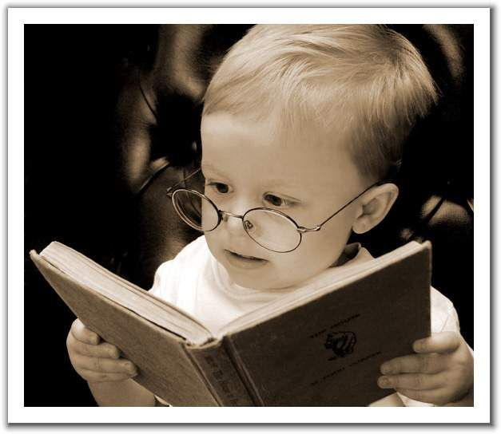
(Written piece—1 page minimum)

